Instructor Lab Version*
*(all bolded and underlined information is only found in Instructor’s lab)

Part I: Pollination Exclusion

Background

Pollination is an essential process in the sexual reproduction of many flowering plants (Angiosperms). Pollination is defined as the transfer of pollen to the part of a seed plant containing ovules (Campbell & Reece, 2005). Pollen itself is a powder made of pollen grains, which contain the male gametophytes of seed plants. When pollen from the male parts of a flower contact the female parts of a flower, the pollen grains will germinate and fertilize the female gametophyte in the ovule. Each pollen grain contains half of the DNA (genetic information) that is needed to make a new plant. During fertilization DNA from sperm produced by the pollen grain combines with the DNA that is in the egg cell within the plant ovule, and a new seed is started. This seed will eventually produce a new plant.

The process of pollination can be performed through pollen being transferred by wind and insects to other plants, or by the plant pollinating itself. Insect pollinators, such as bees or butterflies, provide substantial benefits to the diversity and productivity of both agricultural and natural ecosystems (Buchmann and Nabhan 1996). They introduce cross-pollination into plants, which is the transfer of pollen grains from the anther (pollen-producing part) of a flower to the stigma (female reproductive part) of a flower from a different plant of the same species, which leads to diversity in a plant’s genetic makeup. Wind pollination can also facilitate cross-pollination by transferring pollen among plants of the same species Self-pollination is instead the transfer of pollen grains from the anther to the stigma of the same flower or from one flower to another on the same plant. Self-pollination can lower the fitness of plants by lowering genetic diversity.

Outcrossing, or cross-pollination is one of the methods of pollination required by plants to reproduce. Outcrossing is often accomplished through the transfer of pollen by wind or an insect vector (e.g. bees). There are other plant species that do not need either process to reproduce because they possess hermaphroditic flowers that are both male and female, and therefore they can self-pollinate. It can be an advantage for plants to reproduce on their own, because this gives them the ability to reproduce in the absence of pollinators. However, even if a plant can pollinate itself to make new seeds, there may be an advantage for a self-compatible plant to be cross-pollinated by either insect or wind pollination. Self-pollination decreases genetic diversity due to increased homozygosity, and this can lead to the expression of deleterious recessive alleles that lower progeny fitness. Thus, cross-pollination is advantageous because it maintains genetic diversity, which can increase the health and probability of survival of offspring plants. This fitness advantage can sometimes be seen early on in plant reproduction in the quantity and quality of fruits produced, with fruit produced via outcrossing being more numerous and bigger.
Some follow-up questions to ask students:
From what you’ve read, what are two ways a plant can produce fruit and new seeds?
What role do insects play in plant reproduction?
Why are pollinators potentially important for plant reproduction even if a plant is capable of self-pollination?

Word Bank

Plant Reproduction: |  | Genetics:
Gametophytes  Germination  Fertilization | Fruit  Anther  Stimga | Homozygosity  Alleles  Fitness

Lab Objective

The purpose of this lab is to better understand plant physiology and plant mating systems through comparison of pollination transfers through insects and self-pollination. By using the wild strawberry, Fragaria virginiana, as our experimental plant, we will learn more about differences between cross- and self-pollination. Fragaria virginiana has female flowers and hermaphroditic flowers.* In this experiment we will only examine hermaphroditic flowers, which have both male and female reproductive organs. Hermaphroditic flowers can self-pollinate or can be cross-pollinated by insects carrying pollen from other flowers.

*Female flowers require insects to carry pollen from another flower (on the same or on a different plant) for reproduction, and so bagging them will prevent reproduction altogether, whereas individual hermaphroditic flowers can self-pollinate (bagged or not) or they can reproduce via pollen carried by insects from one flower to another.
You will learn about the significance of pollinators by conducting a pollinator exclusion experiment. Pollinator exclusion experiments are used to determine the effectiveness of plant pollination vectors by physically preventing pollinator access to flowers. Certain flowers are covered to prevent pollinators from visiting them, while pollinators are permitted to visit other “open” flowers. Thus, this experiment has two experimental treatments:

[1] Exclusion treatment: flowers that cannot be cross-pollinated.
[2] Open treatment: flowers that can be cross-pollinated.

Observations are then made on which flowers develop seeds or seed-bearing fruit and the quality of the fruit produced. At the end of the experiment, you will compare the number and quality of fruit produced by each treatment. Here, we define fruit “quality” as the mass of fruit.

Do you think fruit number and quality will differ between treatment groups? If so, how? Why do you think treatments will differ? Brainstorm with your classmates and write your predictions below.

Prediction

________________________________________________________________________________________________________________________________________________________________________________________________________________________________________________________________________________________________________________________

Based on your predictions, form hypotheses regarding your expectations for how fruit number and mass will differ between experimental treatments.*

*Students should be able to form two hypotheses. If the instructor wishes to pursue this level of complexity, students can be guided to create two sets of two hypotheses: a null and alternative for number and for quality.

Hypotheses*

________________________________________________________________________________________________________________________________________________________________________________________________________________________________________________________________________________________________________________________
*Null hypothesis for the experiment is that there will be no difference between the quality and number of fruit produced between the flowers that are bagged from insect pollination and the flowers that are open to insect pollination. Alternative hypothesis will show that there will be a difference in the pollination experiment between the un-bagged and bagged flowers.

Materials
- Mesh/bridal bags
- Paper & Pencil
- Scissors
- Flag Tape
- String/Twisty Ties

Laboratory Activity
1) Create bridal bags:
a. Obtain bridal veil fabric that is fine to prevent access from insects like bumblebees or flies
b. Cut fabric into at least a dozen 3” x 3” squares.
c. Weave a piece of string or wire along the bottom of the material to create a drawstring for the bag (prevents any bugs from crawling in)

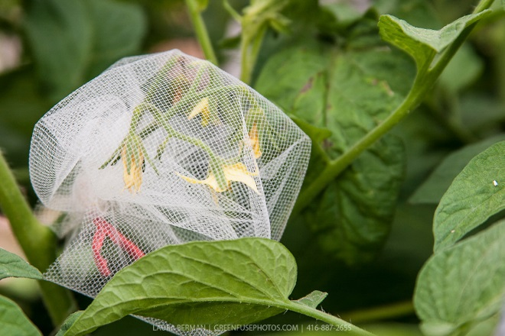
Figure 1. Bridal bag over cluster of tomato flowers.

Bagging and tagging flowers that are more than needed is good because we won’t know until flowers open if they are female or hermaphroditic Want as big a sample size as possible; probably want at least 100 bags to work with; can bag and tag flowers as they bloom.
2) Go to the garden and on each plant, assess how many buds are about to produce flowers. Determine the number of flowers you will include in the experiment, as it will depend on availability.
a) Make sure to choose an equivalent number of flowers to be bagged for the exclusion treatment and for the number of flowers to be left open. Each plant will have both treatments of un-bagged and bagged flowers because the flowers are the experimental subjects we are working with for this lab, not the plant itself.

3) Place the netting bags on half of the budding strawberry flowers you have identified. Secure mesh bags on the buds (again it’s key that the flowers be bagged ahead of blooming). The flowers are bagged with these fine-mesh bags in order to exclude pollinating insects (like bumblebees) but still allow for the passage of sunlight and water.

4) Make sure to mark and tag equivalent numbers of flowers with flag tape for both the bagged and un-bagged flowers, making sure to mark each experimental plant used. ID with numbers so that each plant has a unique number and each flower per plant has a unique number as well.
5) Make sure to also tag (with string) the bagged and un-bagged flowers that are being used in the experiment so that all flowers being monitored can stay accounted for. *Note: While waiting for production of the experimental flowers, you may use flowers that aren’t used in the Part I experiment for the Part II: Flower Dissection lab.

6) After flowers are open, identify whether each flower is female or hermaphrodite. Note that bagged hermaphroditic flowers can self-pollinate, but bagged females cannot. Thus we cannot compare fruit for bagged vs. non-bagged females, and so they should be excluded from the experiment.

a) Visible differences between female and hermaphroditic strawberry
flowers to look for: 1) Hermaphrodites have anthers on long filaments that are filled with pollen, so they are yellow and, 2) The female flowers have white anthers devoid of pollen on short vestigial filaments.

7) Allow for plants to grow, flower, and produce fruit for the next couple of weeks while observing and recording noticeable observations through notes and pictures. Look for what types of organisms visit the plants and note any changes/differences of the fruit while comparing it to the netted plants and the control.

8) While waiting for the production of the fruit from these plants, you can continue with Part II: Flower Dissections once the untagged flowers come into bloom. Also, collect untagged fruit as they ripen during the season.

9) Later in season, if available, collect fruit from the flowers you bagged and tagged as it ripens. Fitness is measured through comparison of bagged flowers from open flowers by counting proportion of flowers per treatment that produced fruit (number of fruit/number of buds tagged) and weighing the fruit mass of the strawberries. If any strawberries are eaten during this procedure, still count it and note that it was unable to be weighed.
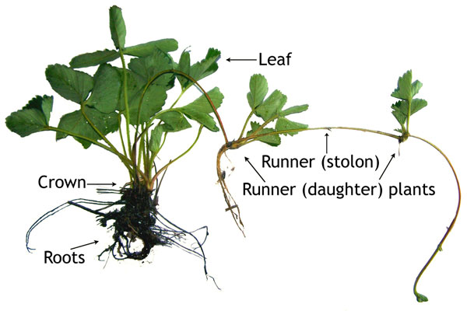
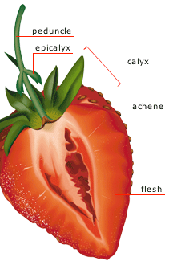

Figure 2. [Left:] Strawberry plant. [Right:] Seed-bearing fruit of strawberry plant.

 |  | Flower ID | Bagged/Unbagged | Weight of fruit (g)
Hermaphroditic Flowers (bagged) | Plant #1
 | Plant #2
 | Plant #3
Hermaphroditic Flowers (unbagged) | Plant #1
 | Plant #2
 | Plant #3

Can always add more columns/rows to graphs for students depending on how many plants and flowers are accounted for during the experiment.

Part II: Plant Dissection

Purpose
The purpose of the dissection lab is to better understand plant reproduction and their mating systems through dissecting and analyzing the physical reproductive parts of the strawberry plant, Fragaria virginiana.

Prediction

___________________________________________________________________________________________________________________________________________________________________________________________________________________________________________________________________________________________________

Hypothesis

___________________________________________________________________________________________________________________________________________________________________________________________________________________________________________________________________________________________________

Materials
- Samples of Pollen
- Glycerol jelly (optional) mounting medium (for pollen)
- Slides & Cover Slips
- Flowers & Fruits
- Exacto knives
- Dissecting/Compound Microscope
- Forceps/Tweezers
- Small Envelopes (for collecting pollen)

Procedure
1) Gently cut a flower from each species of plant for further evaluation in the lab.

2) Collect samples of pollen from the different flowers by shaking the flower pollen into an envelope, making sure to use a different envelope for each flower. Label the envelope.

3) Dust a little of the pollen in a drop of water on a slide and cover with a slip. Using a compound microscope, locate the pollen grains under low power (10x) and focus under high power (40x or higher). Make a drawing in the “Observation” section. *

*Caution students against highest setting, which usually requires oil immersion.

4) Next, fully examine your flower. Locate the petals and record the number of petals and the color of them. Draw a diagram of the flower again in the ‘Observation’ section below. Make sure to label the pedicel, petals, and corolla.

5) Gently remove petals from the flowers and locate the stamens. Each stamen consists of a thin filament with a pollen filled anther on the tip. Diagram and record the number of stamens, and then remove.

6) Locate and also again diagram the pistil, stigma, style, and ovule.

7) Slice the ovary in half lengthwise and mount a half of it on a slide. Examine the ovary section under the dissecting microscope, while making sure to look for small, dot-like structures that fill the ovary half. These are the ovules and each ovule contains an egg cell that is not visible under low power of a microscope. Again, identify and sketch the ovary and ovules.
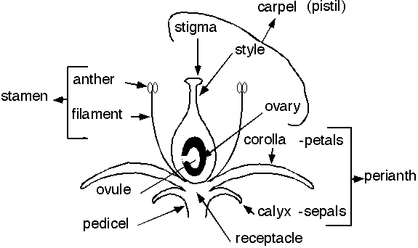

http://ag.arizona.edu/pubs/garden/mg/botany/images/p20large.gif

Data/Observations

1) Pollen Diagram

2) Number of Petals: ___________________________

Color of Petals: ___________________________

Diagram of flower:

3) Number of Stamen: ________________________

Diagram:

4) Number of Pistils: __________________________

Diagram:

5) Diagram of the ovary and ovule

Discussion Questions

- Define self-pollination:

- What is cross-pollination?

- Where in the flower is meiosis occurring?

- Compare and contrast sexual vs. asexual reproduction in plants:

5. Explain why approximately half of an individual plant’s DNA sequence comes
from each parent plant.

6. Study the following flower characteristics and indicate which modifications
are for insect, and which are for wind pollination:

  - Brightly colored petals –
  - Perfume glands –
  - Long, protruding stamens –
  - Nectar glands –
  - Pistils with lengthened styles –
  - Flowers lacking petals –

7. What are the male and female gametes in a flower?

