Soil Composition

Topics: Soil Composition, Classification
Grade Level: 9-12
Summary: Students get their hands dirty while investigating the soil composition of samples taken from the school garden. Soil horizons and composition are explored using core samples and allowing soil to separate in water. Following detailed observations, students classify soil types using the unified soil classification system.

Research Question: What is soil made of?
How does soil composition change throughout the garden?

Pre-Lab
Students discuss what they know about soil. Talk about composition-in terms of a recipe?
*compare silt, sand, and clay

Materials List:
- Soil Core
- White towel or sheets
- Magnifying Glasses
- Rulers
- Colored Pencils
- Lidded Jar Filled ¾ Full With Water
- Unified Soil Classification Triangle (laminated?)

Procedure:

1. In the garden, take a soil core making sure to get at least 3 inches of soil. Lay the soil core on a paper towel.

2. Use colored pencils to draw the soil core.

3. Place the soil into the jar filled with water. Put the lid on the jar tightly. Take turns shaking the sample for at least 30 seconds. Start a timer and set the jar down on a flat surface and let it sit.

4. Make observations about the jar after 30 seconds, 1 min, 2 min and 5 min.

5. Each member of your group will take a small sample (a pinch) of soil and place it in your hand. Look at the soil classification triangle. Using your fingers to feel the soil work with your group to classify the soil.

Observation: After you have take your soil core, please draw it below. Use colored pencils and make sure to show the different layers of the soil. Make sure write at least two qualitative observations next to your drawing.

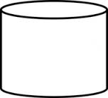
Prediction: What do you think will happen when you mix the soil with water? What will happen after you let it sit still for 5 minutes?
____________________________________________________________________________
____________________________________________________________________________

Observation:

What does the jar look like after 30 seconds? ________________________________________________________________________________________________________________________________________________________

What does the jar look like after 1 minute? ________________________________________________________________________________________________________________________________________________________

What does the jar look like after 2 minutes? ________________________________________________________________________________________________________________________________________________________

What does the jar look like after 5 minutes? Draw a picture below and label any layers.
____________________________________________________________________________

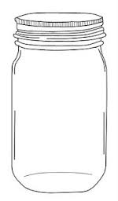
Classification:
Take a sample of soil in your hand and record 1 qualitative observation.
____________________________________________________________________________

Look at the soil classification system below. With your group decide how much clay, silt, or sand you have in your soil. Remember the samples from the beginning of class.

Percent Silt: ____________ Percent Clay: _____________ Percent Sand: ___________
Type of Soil: ___________________________________________________________________
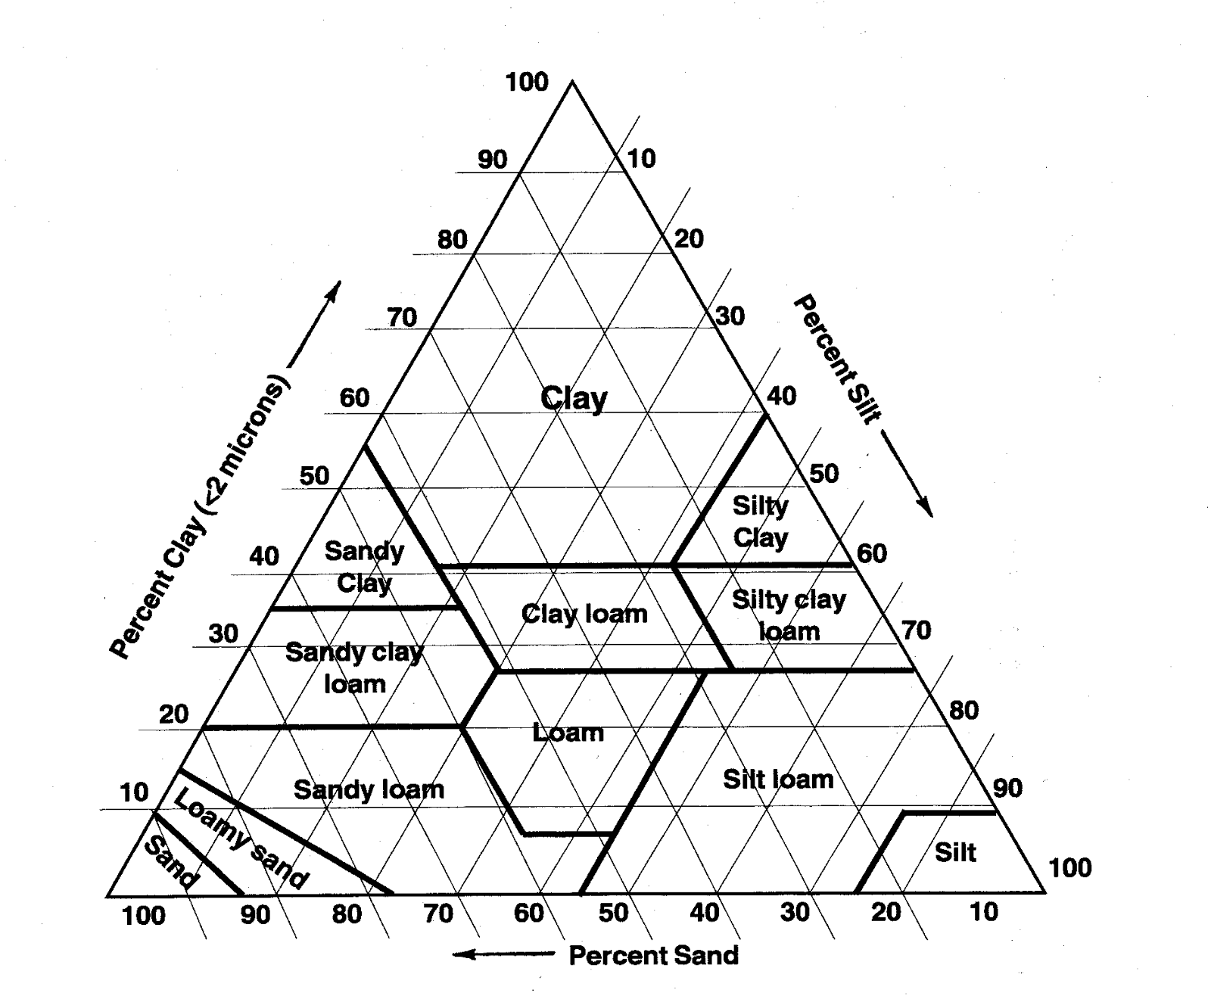
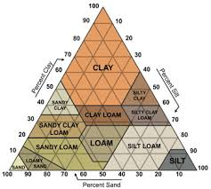

Post-Lab
Write a recipe for the soil you would like to use in your garden.

